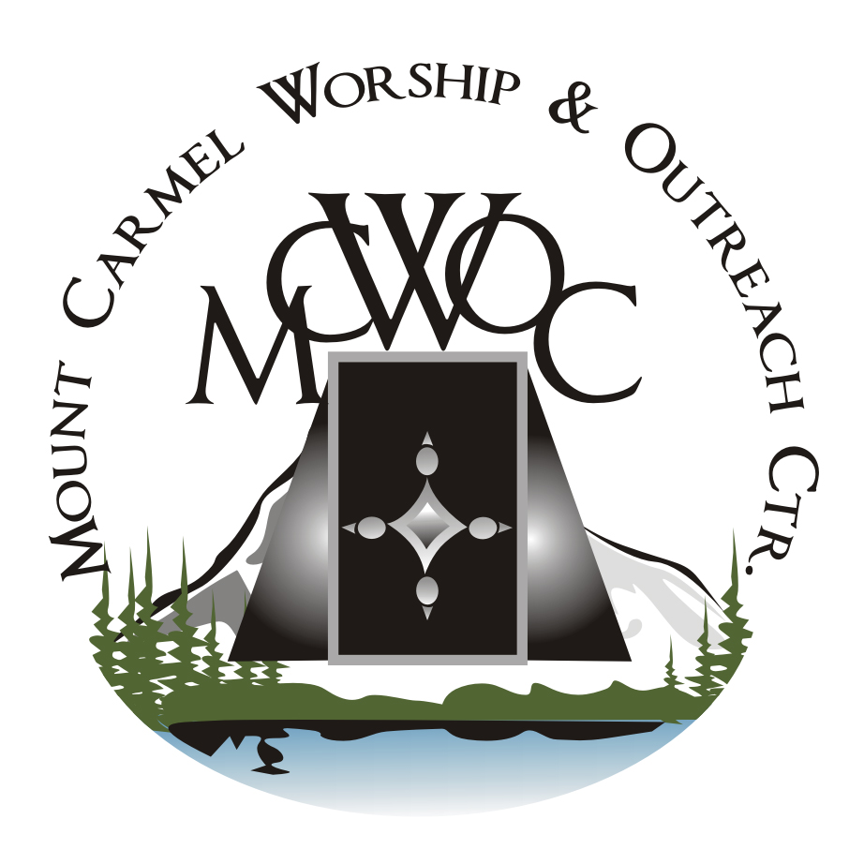
Mount Carmel Worship and Outreach Center Inc.

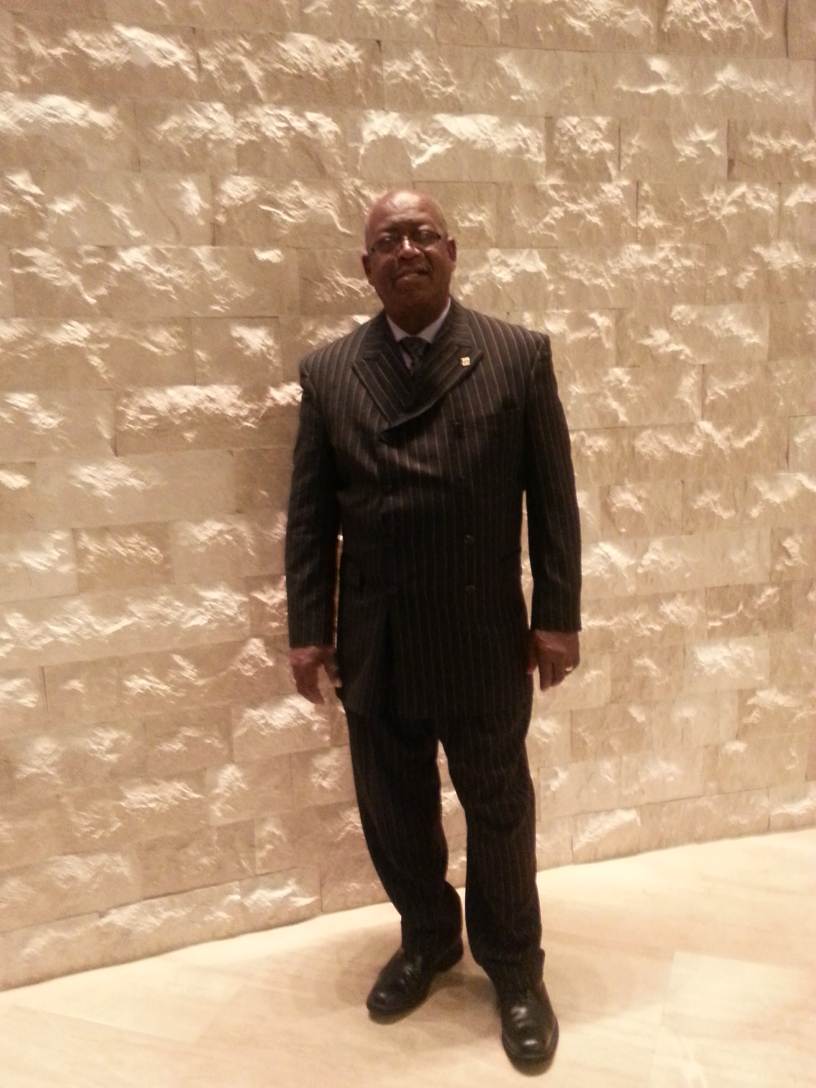

Pastor Dr. Glen Lawrence

Pastor Dr. Glen Lawrence is the Senior Pastor of Mount Carmel Worship & Outreach Ctr and has led the church for fourteen years. Dr. Lawrence was called to ministry at the age of 22 and served as a Deacon and President of the Youth Fellowship Ministry at Gospel Auditorium Church in Jamaica, West Indies under Pastor Clinton Hoffenden who was his mentor and pastor. At a young age Reverend Lawrence had an ‘all-consuming’ desire to serve, preach and teach the word of God and to minster to people. Pastor Lawrence is the fifth child of eight children born to Sydney and Ethlyn Lawrence. His parents instilled the gospel of Jesus Christ to him and stressed the need for love, truth, honesty and service in his teen and adult years. Reverend Lawrence believes in preaching and teaching the word of God, and just as importantly, he believes that we must "live" the word. Dr. Lawrence has been married to Evangelist June Lawrence for 25 years, and has three children, Darin, Sidney and Brianna. The family serves together in the ministry and offers encouragement, affirmation and educational/economic assistance to the many community members whom they serve.

Dr. Lawrence has an extensive history working with various ethnic communities in Brooklyn. He works vigilantly serving as an advocate for undocumented immigration issues. Pastor Lawrence spends a lot of time passionately organizing ‘kingdom building’ community projects. His favorite scripture verse follows: ‘One thing have I desired, that I will seek after, that I may dwell in the house of the Lord all the days of my life. To behold the beauty of the Lord and to inquire in His temple.’ (Psalm 27:4)

Pastor Lawrence’s church leadership has fostered a love for grassroots activism/evangelism which he uses to administer adult/children computer training, reading literacy programs, health awareness community events, food distributions and coat/toy drives. He promotes these programs to advance opportunities for ministry by linking educational/knowledge-based resources with human needs. His ultimate goal is to run outreach programs that empower, encourage, and stimulate thought processes which impact change and bridges barriers that prevent independence. Dr. Lawrence also leads activities which include organizing a self-funded bi-monthly neighborhood book drive, where he distributes hundreds of quality books to children for free. The mission of Mount Carmel and Worship & Outreach Ctr is to continually serve the Lord and His people with all of our might.

